**ChequeBook Reconciliation System**

Project Leader : Maaz Rafique

Project Leader Student ID : SP15-BS-0017

Student-1 : Syed Muhammad Ali Naqvi

Student-1 :ID FA15-BS-0029

Student-2 : Noman Arshad

Student-2 ID : SP15-BS-0027

Project Supervisor : Dr. Asim Imdad

Associate Professor

Project Co-Supervisor : Miss Samia Bashir

1. Motivation

When a human works continuously then chances of mistakes, that whether cheque is correctly filled or not become more evident. So to solve that problem we are making this project to automate the process of verifying and authenticating cheque.

So the reliance on human being is excluded. And chances of error will be very minimal.

1. Overview
   1. Significance of the Project

This project is significance because it concerns a sector that is of critical importance to banking sector a lot of other industries where digits and alphabets plays a critical role in their business model will benefit from this. Human cost will also be reduced because of this automated cheque in place.

* 1. Description of the Project

The problem discussed above will be solved by using concept of deep learning and image processing. With the help of deep learning we train our model to recognize numbers written in words in human writing. The amount written on the cheque will be extracted with the help of image processing and then we break them words by words and identify them with our trained model and then a pattern will be designed that sum-up those break parts into its original figure written in words and then we compare the whole amount with the figure written in digits.

* 1. Background of the Project

The main purpose of this software is to facilitate the people, help them in order to give them secure platform to verify their cheque’s amount in words and in numbers that they have write by scanning the cheque through software and compare both the amount in words and amount in numbers whether they are matching or not. The research we have done in the development of this software is to check whether someone has make any type of software which is related to scan the cheque and compare the amounts in words and in numbers. So there is not a single software which work on scanning cheques and comparing amounts. Other related software like we will give input in words and will give output in numbers and in your native language.

1. Methodology
   1. Design phase

In the design phase, firstly we will gather the data for our system i.e. maintaining the data sets. By using data sets we will first observe it and then categorize the data in respected manner so we can easily use them in our scripts. This categorize data will be break into two parts namely training set and testing test.

* 1. Implementation phase

In this phase we will setup the development environment containing python language, Spyder IDE, OpenCV library for image processing and Keras And TensorFlow for conventional neural network. Creating scripts using OpenCV library to crop the data sets to train our neural networks. Making scenarios to break the amounts given in cheque and then compare the data of cheque with the system’s data set(Trained Model) which we have gave to the system.

* 1. Testing phase

In the testing phase, we will test our system by providing testing data set and then observe the results according to the data set(Testing data set) we provide to the system. By focusing on the results we will measure the accuracy of the result.

* 1. Evaluation phase

The evaluation criteria for this project is by measuring the accuracy of the result that how accurate our system will give output. The other evaluation criteria for this project is the output time that how much time will take to give the accurate output if the output time is in between 1 minutes 30 seconds , so the project will be consider as successful.

1. Features

Unique Dataset:

The data set use in this project is self designed , 100% original and uniquely categorized into two parts 1) Training Data Set 2) Testing Data Set.

Recognizing the Human Writing:

The main feature of this project is that we will train our system through data sets that it will easily recognize the hand writings of human on cheque and identify the amounts written in words. The system will scan the cheque to perform this action. After scanning the cheque, system will observe the amount written on cheque and then uses the trained data set to find similarity.

Comparing The Amounts:

After recognizing the human hand writing on the cheque, the system then compare the amount in words with amount in numbers in the cheque and then give output which shows that if the amount in words and in numbers matches or not.

1. Project Planning

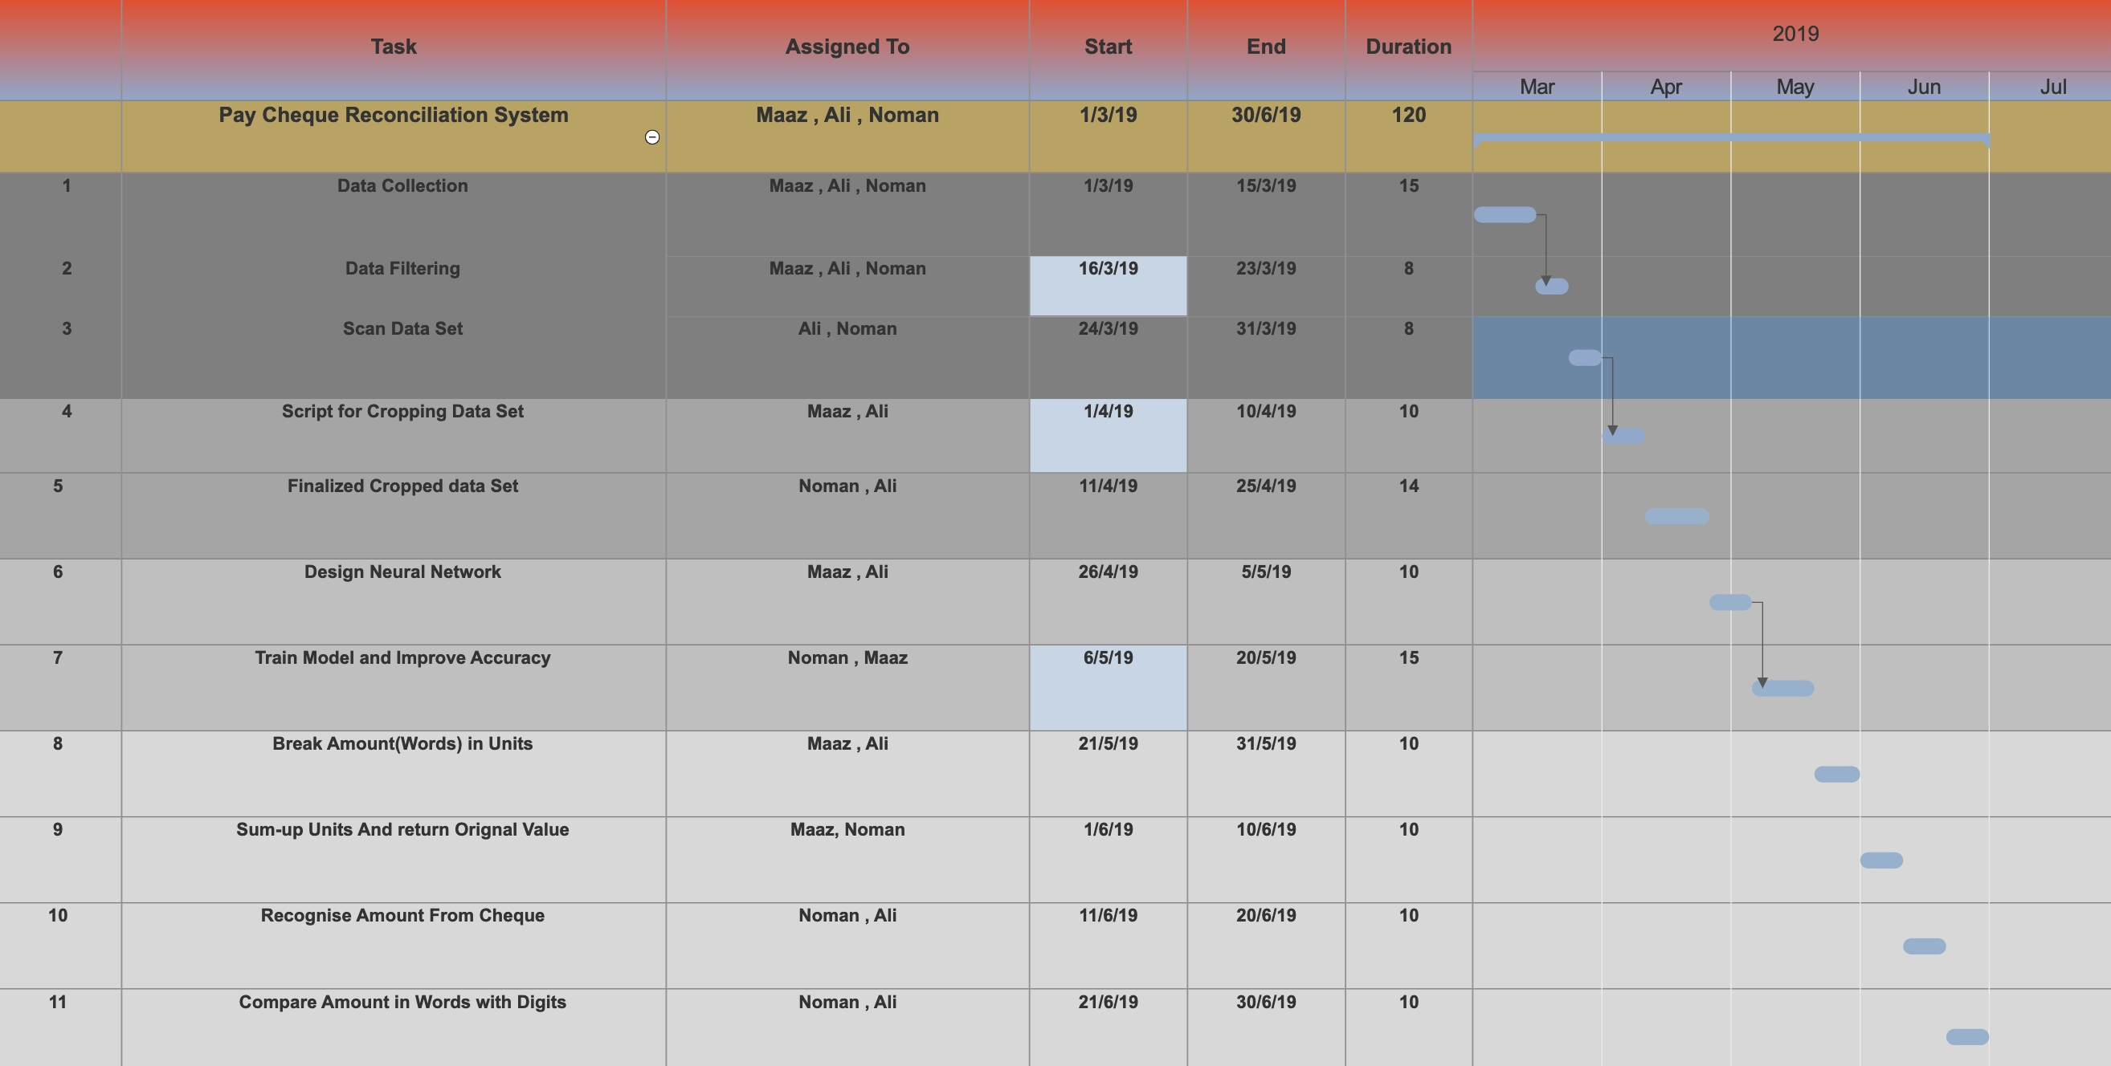

1. Hardware and Software Requirements

Hardware:

The hardware requirements for the project are as follows:

• PC/Laptop

• RAM 8GB and above.

• GPU Nvidia GT 730 and above.

* Processor: Core i5 3rd Gen. and above.
* Scanner.

Software:

The software requirements for the project are as follows:

● Anaconda.

● Spyder.

● OpenCV.

● Keras.

● Python Language.

● TensorFlow

1. Diagrammatic Representation of the Overall System

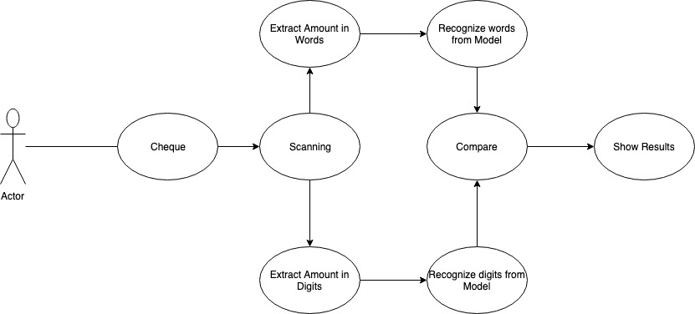

1. References

[1] https://github.com/tsaqib/number-to-bangla

[2] Jhttps://github.com/sebthemonster/currency-in-words